- A Computer Vision Based Web Application for Tracking Soccer Players
  - Research Goals
    - Web-app for soccer, two fundamental components
      - Social Network: typical features adapted to soccer reality
      - Professional component: considered as Soccer Resource Planning, a system for acquisition and processing infromation to meet all soccer management needs
    - Automated platform:
      - Process live images from cameras
      - Add features which allow analysis of soccer match
  - Methodology: 5-module structure
    - Field module – computer vision
      - Detect ball and player location: 5 stages
        - Detection of soccer pitch
          - Detect the pitch by thresholding HSV frame, taking green pixels
          - Eliminate areas outside the pitch:
            - Chose central point of image as the seed, has to have green color
            - Recursively use 3x3 neighborhood. All green center with green neighbor are kept.
            - Canny edge detection and Hough transform to detect lines, to detect limits of the pitch
            - Remove the area outside the limits
            - Final image is the pitch with black blobs inside (for next stage)
        - Detection of players and ball
          - Dilation and erosion filter, then 9x9 medium filter => image where players were better defined and specific noise regions were removed.
          - Apply vertical masking to connect separated regions of a player
          - Check that each blob corresponding to a possible player has at least one edge contour correspondence.
          - Check if the final blob region of each player doesn’t had more than 10% of green pixels
          - Detect ball by detecting the white color pixel percentage, with the size and shape considered so as not to mistaken with players or pitch line: remove blobs with more vertical-rectangular shape, and use Hough transform to remove pitch lines
        - Assignment of players to their teams: color based
          - Select the players, compute Hue, taking average values to separate
          - Numbering of players can be done with position on the pitch, or use team sheets as inputs
        - Tracking of players and ball
          - Distance of players from current and previous frame
          - If two or more at the same distance, player assigned to one has the nearest Hue value
          - No players in current frame near position compared to previous frame, then player with same color as one in previous frame was looked up using circular areas with increasing diameters with center as original coordinates. A predicted trajectory from the previous 5 frames to limit within the sectors of the search
          - Situations which particular player was not tracked during a long frame set, search from the position where he was lost using the circular areas with increasing diamters. First blob found that was not tracked and has the same Hue value was assigned as the lost player
          - New players lost in majority of the frame that comes in are considered new player to track (differ from lost on a previous frame). Player that appear at left or right, top or bottom depending if there has a zoom applied considered new player to track.
          - Verify existence of collisions. All blobs correspond to players very close in positions were associated with a single blob. When collision ends, check the Hue and reassign
        - Computation of their pitch location
          - Perspective transformation. Using relative distance of players to the lines on the pitch
          - Pixel meters has to be calibrated instantly as camera moves, using the lines
      - Verify match tactical plans, Game analysis
        - Heat maps: matrix with size HM (size of the pitch)
          - Start with HM = [0]
          - For each frame, a cross-multiplication uused to get corresponding positions of each player to corresponding entry in HM matrix
          - Once all frames and players are processed, matrix is normalized, each entry divided by maximum element
          - Build the output image, setting color opacity of the pixels that form the heat map
        - Passes maps:
          - For every frame
            - distance between each player and the ball is calculated
            - Ball enters in a player’s radius, tag the frame and player, and ball vectorial velocity and direction are calculated using curret position and its position before
            - If ball leaves player’s radius, then vectorial velocity and direction are also calculated
            - Velocity and direction are then subjected to a set of conditions, to check if it’s a pass or not (check significant change in ball’s direction or velocity
          - Pass log is built, containing list with intervening players numbers, teams, and time of the pass execution and reception
        - Ball loss maps – similar to pass maps:
          - Generated using pass log
          - Count the pass to the other team instead
          - Distinguish failed pass from failed dribbling by consider the distance between position where pass was made and where it was received
    - Center module
      - data and computational procedures are congregated
    - Coach module
      - Coach and technical staff inputs and gets access to detailed information of every topic related to the soccer match, scouting, medical department
    - Player module
      - Send specific information to the players
    - Presentation module
      - Semi-automatic presentations are prepared for the players in preparation moments
  - Results
- An Integrated Real-Time System for Soccer Analytics
  - Research Goals
    - sport tracking system for player statistics and system for human expert annotations
    - Allows the game analytics to automatically play back a tagged game event or extract a video of events extracted from the statistical player data
    - Provide live, real-time analysis and video playback using algorithms to enhance image quality, parallel processing, and offloading to co-processing units
  - Methodology
    - three subsystems: video, tracking (sensor), and analytics:
      - The video subsystem utilizes multiple synchronized cameras to record high-resolution videos of the soccer field. The videos are processed and stored using a pipeline that includes calibration, stitching, and encoding.
      - The tracking subsystem uses sensors on players to capture their exact positions. It integrates with the camera views to track individual players or groups of players.
      - The analytics subsystem reduces manual labor by equipping the trainer team with tablets or mobile phones to quickly register predefined events or provide textual annotations. The registered events are stored in an analytics database and can be automatically extracted and displayed along with a video of the event.
    - Video subsystem:
      - Camera setup
      - Panorama picture generated using stitching (homography stitching)
    - Tracking subsystem:
      - Combination of videos and sensor to detect players with low deviation
  - Results

- Football analysis using machine learning and computer vision
  - Research Goals
  - Methodology
    - Player, team, ball detection
      - Coordinates for bounding boxes around players and the ball
      - Ball possession is determined by proximity of ball and player bounding box
      - Color masking used to identify the player’s team, filtered using color range
    - Halfway line detection
      - Filter out non-playing field areas by excluding colors that are not shades of green
      - Also prevents edges from being detected in areas such as the stands
      - Cooky Canny edge detection on the filtered frame
      - Probabilistic Hough transform applied to extract the lines of the image.
      - Filter out all the lines that aren’t the halfway line (only line that is vertical), and span out most of the screen
    - Penalty box line detection
      - The detection of the penalty box line is done in similar fashion to the halfway line detection.
      - The Hough transform is then once again to extract the lines of the image
      - filter out the lines that are not wanted
      - The angle of the box line is different depending on which side of the field the camera is pointing
      - Since there are more lines that have the same angle as the box line, some more filtering needs to be done. In this case, the line that is furthest to the center of the field is the line that is most likely to be the box line.
    - Thirds approximation
      - If the halfway line is visible, it gets translated in both directions to act as boundaries for the middle third. The lines are also rotated slightly to better follow the actual orientation of the field.
      - If instead the penalty box line is visible, that line gets translated towards the middle of the field. This line is also rotated to account for the orientation of the field
    - Attack zone approximation
      - In the case where the halfway line is visible: try and find the contour of one of the centre circle halves and find the extreme points. The topmost and bottommost points are then translated along the halfway line out from the circle, to more accurately split the playing field in three roughly equal thirdss
      - The same approach is used in the case where the penalty box is visible, but instead of using the centre circle as anchor points, the semi-circle attached to the penalty box is used.
      - The filtering of the contours is done similarly in this case. The very small and very large contours are filtered away, and only contours with their topmost and bottom most points very close to the penalty box line are kept.
    - Determining ball position
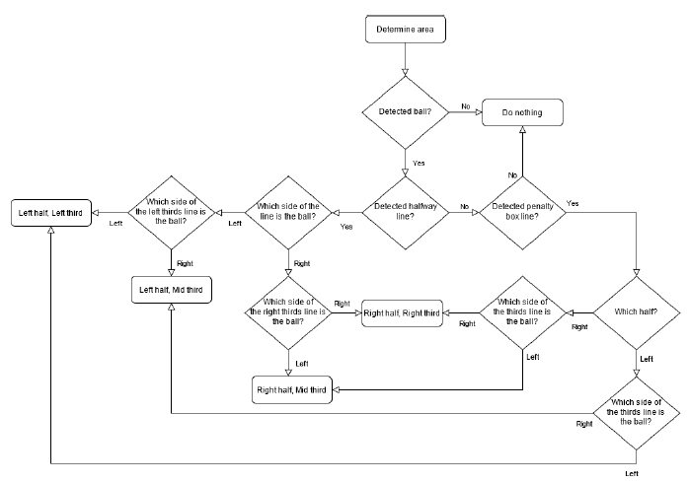
    - Updating and summing up statistics
      - Last step of system loop is the step that actually updates and increments all different metrics
  - Results

